OPENING WORK ORDERS IN CORRIDOR
- Go to “Work Order” (icon is a clipboard with a wrench)
- Fill in all areas in yellow
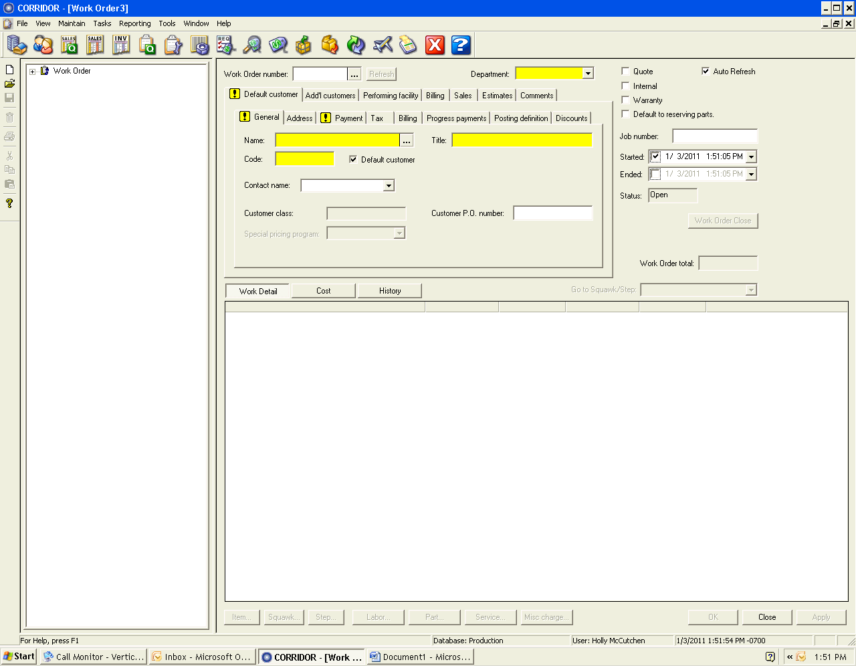
- Under “Department” use the drop down box and select “Retail”
- Under the “General” tab, type in the name Precision Aircraft Management, then click “Scan”. Corridor will search its database to find the company details.
- Go to the “Payment” tab and select “on account”.
- To save changes click “apply”. This will save without leaving the current screen.
- Under “Item” type “Current month hangar rental for N124UV”, apply, close.
- Enter Squawk: type “Current month hangar rental for N124UV”, apply.
  - Click “Squawk Approval”, click “Approve for Service”, Close, Close.
- Under the squawk, expand and go to the “Billing” tab.
  - Under Rev/cost description, uncheck the box next to “Squawk is taxable” (hangar rental is a flat rate and not taxed).
- After all yellow areas are filled in, view invoice by going to the left hand pane and expand “Work Order”.
  - Expand “Reports”
  - Expand “Work Order Invoice”
  - Preview to ensure accuracy
  - Print

After opening the work order, the next step will be to bill the account. See billing in this section.

When all steps are complete:
- Fill out Work Order Card and create a black work order folder.
- Fill out a Work Order Checklist.
- Include the Preliminary Invoice and the Credit Card Receipt in the black folder.
- Send to Adam McDowell for review and Closing.

